

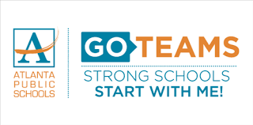

2024-2025

GO Teams Uniform Committee Meeting Agenda

Date: Thursday, December 5, 2024

Time: 5:00pm

Location: Microsoft Teams <https://teams.microsoft.com/l/meetup-join/19%3ameeting_YmMyYzJkNWQtYzU3MS00ZjZhLWJmZWUtMjcxODUxMmM4NzE1%40thread.v2/0?context=%7b%22Tid%22%3a%220d95ef40-a0dd-4318-9098-5e10f876f635%22%2c%22Oid%22%3a%228f77ccba-ab1c-49d6-8c54-74572f4d6078%22%7d>

Purpose of Meeting-

To develop a stakeholder engagement plan to receive feedback on implementing a uniform and its components, if adopted. (The Uniform committee will meet on this day and produce the recommendations that will be presented to the stakeholders).

I. Welcome/Purpose of meeting

a. Introduction of members

II. Meeting norms

III. School Uniforms

a. Discuss ways on how to receive the community’s input.

b. Produce a date where we will distribute a survey/Google Doc.

IV. Calendar of future meetings

1. Go over meeting dates.

V. Create the next course of action steps.

VI. Adjournment of Meeting